Role Specification

Chief Operating Officer



**Scott Texeira**

Scott.Texeira@egonzehnder.com

t. +1 650 847 3075

m. +1 650 387 6922

**Janice Pai**

Janice.Pai@egonzehnder.com

t. +1 650 847 3060

m. +1 650 799 5065

# Company Background

GreyOrange designs, manufactures, and deploys advanced robotic automation systems for warehouses, fulfillment centers, and distribution centers. They are disrupting the warehouse and supply-chain industry with advanced intelligence and unparalleled technology.

Headquartered in Singapore and with US headquarters in Atlanta, GreyOrange operates out of 5 regional locations with R&D centers in the US, India and China. To date, GreyOrange has completed more than 80 fulfilment installations of its technology. GreyOrange is rapidly expanding across the globe clients such as: Nitori in Japan, Flipkart, Delhivery, DTDC, Aramex in India, XPO Logistics in North America and Europe, Sodimac in Chile, Ninjavan in Singapore, Kerry Logistics in Hong Kong, and POS Indonesia.

GreyOrange’s vision is to prepare their customer’s businesses for the future, so that they can focus on what they do best: create, sell, and innovate. Consumer expectations have outpaced warehouse evolution, with e-commerce and services such as store pickup and same day delivery growing, companies are required to reduce their order-to-delivery time while managing increased volume and variability. Intelligent automation provides GreyOrange’s customers the ability to meet these increased business needs by better managing complexity and scalability.

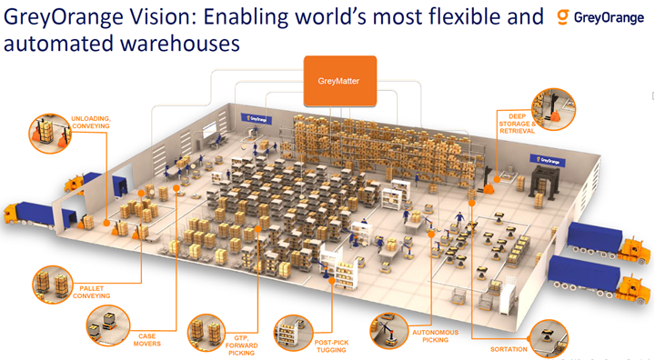

GreyOrange’s intelligent automation product portfolio includes robotic hardware platforms, a state-of-the-art, decision science driven software platform GreyMatter that intelligently manages execution and optimization and collaboration across robotic platforms, and a suite of apps to deliver data-driven and optimized end-t0-end solutions. Key hardware platforms include Butler, an advanced autonomous mobile robotic goods-to-person order fulfillment system, and Sorter, a flexible and scalable automated sortation system. Core to the company’s vision is the integration and collaboration of various hardware platform with the GreyMatter platform to enhance efficiency and accuracy of warehouse solutions.

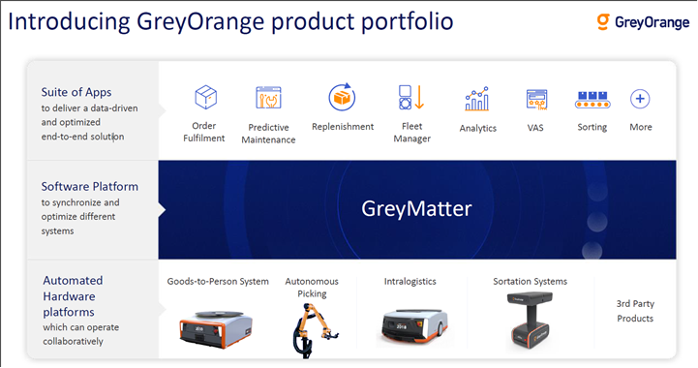

Founded in 2011 by Samay Kohli and Akash Gupta, GreyOrange is one of the fastest-growing AI and warehouse automation companies in a rapidly expanding market. The company and its founders have been recognized by Robotics Business Review, the BBC, Forbes, and MIT Technology Review as leaders of supply chain automation and innovation. GreyOrange has raised over $170M in funding, including a $140M Series C round in September 2018, the largest round ever raised by an industrial robotics company.  The company’s investors include Mithril Capital, a firm created by Peter Thiel, co-founder of PayPal and Palantir, Flipkart co-founder Binny Bansal, Blume Ventures, and Mitsubishi.

GreyOrange emphasizes a culture of customer focus, transparency and integrity. Passionate yet humble, GreyOrange’s leaders drive growth by keeping the needs of customers, vendors and employees top of mind. With a culture of collaboration, the team is active in the creative community, endlessly interested in what’s next, and generally pleasant to be around. With a bias toward action and an analytical mindset looking to the next challenge, the company and its talented workforce are well on their way towards solving global supply chain and warehouse customer needs through intelligent automation.

|  |  |
| --- | --- |
|  |  |
| Website/ <https://www.greyorange.com/>  Video/ <https://www.youtube.com/channel/UCGLcH2hQiILnteafeYh_qOA>  Product Overview/ <https://www.youtube.com/watch?v=WqkFyvmORSI>  Recent Funding/ <https://techcrunch.com/2018/09/06/greyorange-raises-140m/>  CNBC Video/ <https://www.youtube.com/watch?v=78L1-YUBzy4> | |

|  |  |
| --- | --- |
|  |  |

# The Role

GreyOrange is hiring a Chief Operating Officer (COO), a newly created position, as part of a continued growth strategy to disrupt the supply-chain and warehouse industry through intelligent robotic automation systems. The COO will report to the CEO and Co-Founder, and is responsible for the scaling and development of GreyOrange’s operational capabilities. At the core of it, the COO will carry operating responsibility of enabling GreyOrange’s product platform to achieve its commercial potential.

**The role’s key responsibilities will include:**

* Design, development and execution of a comprehensive operations strategy
* Plan, design & operationalize new commercial engines for sustainable revenue growth
* Globally develop approach and support for channels, alliances & partnerships, and scale revenue through channels
* Drive sustained growth in orders, revenue and operating profit
* Build, develop, improve, influence and expand relationships with key partners and customer groups
* Deliver value to clients by optimizing the client experience and maximizing client growth and retention
* Drive best in class business processes that yield productivity enhancements and facilitate the delivery of complete solutions to the markets they serve.
* As a key member of GreyOrange’s Executive Leadership Team, collaborate with senior leadership to develop strategic goals and turn those goals into specific operating and business plans that are executed
* Manage a geographically dispersed team that include but are not limited to Business Development, Key Account Management, Marketing, Operations, and Supply Chain. Provide matrix oversight of Region CEO’s.
* Overall accountability of operations team in the execution and delivery of all aspects of the delivery of GreyOrange’s solutions
* Develop high-functioning teams and instill accountability by providing clear goals and direction, motivation, and performance feedback.

# Reports to

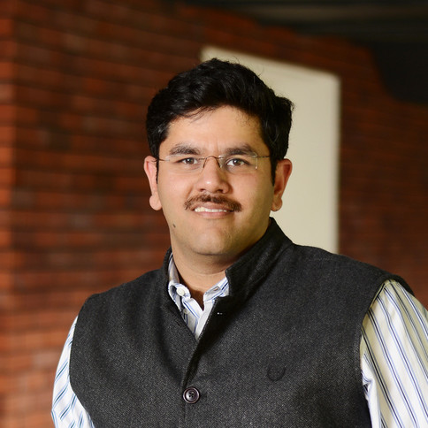

**Samay Kohli,** Chief Executive Officer & Co-Founder

The extraordinary growth pace of GreyOrange speaks volumes of Samay’s contribution as a leader. His aim is to acquire one of the largest market shares in the automation industry globally. Samay’s passion for Robotics started about a decade ago. He was part of the team that created one of India’s first indigenous humanoid robots – AcYut. Samay, along with Akash Gupta, has participated in robotics competitions across 13 countries; winning Gold medal at the ROBOlympics in 2009. An alumnus of Birla Institute of Technology and Science, Pilani, India, Samay has been a keynote speaker at several prominent technology conferences around the world, and has been featured in many publications including Forbes Asia, Economic Times, The Fortune and has made his way to MIT Technology Review’s global list of “35 Innovators under 35”.

In recent years Samay has led the expansion of GreyOrange into Asia-Pacific, Europe and the Americas, and some of the biggest customer sites can be found in Japan, Latin America and USA. Samay is based in GreyOrange’s US Headquarters in Atlanta, Georgia.

|  |  |
| --- | --- |
|  |  |
| <https://www.linkedin.com/in/ksamay/> | |
|  |  |

# Role Location

The role will be based in the company’s US headquarters in Atlanta, Georgia.

# Candidate Profile

The ideal COO will have experience in sales, marketing and operations along with entrepreneurial experience as a founder / early employee in a company with hyper-scale growth. S/he will possess the ability to think both strategically and operationally, and drive change in a complex, and high-performance environment at a global scale. S/he has a team-oriented outlook, inspires collaboration and builds bridges between cross-functional organizations. The successful candidate will be comfortable in all settings, interfacing directly with customers and partners as well as operating at all levels of the organization. S/he must have a global viewpoint, adept and comfortable in any culture and setting.

|  |  |  |
| --- | --- | --- |
| Leadership Experience | Must have | Nice to have |
| Proven senior executive with hands-on, global experience at scale | **** |  |
| Proven track record of scaled growth | **** |  |
| Founder / Entrepreneur |  | **** |
| Sector and Business Experience | Must have | Nice to have |
| Scaled a Software-as-a-Service business through expansion into new markets followed by sustained growth | **** |  |
| Built / managed an enterprise technology business | **** |  |
| Established sales channels & supporting infrastructure | **** |  |
| Demonstrated productivity and commercial improvements through KPIs | **** |  |
| Proven success across functions spanning operations, sales and marketing, supply chain, and field operations in expanding markets | **** |  |
| Visionary leader with a “practical, pragmatic vision” to lead in a fast-changing business | **** |  |
| Experience in recruiting, developing, and coaching high productive, high potential cross-functional teams at a global level | **** |  |
| Strategy and/or strategy consulting |  | **** |
| Industry experience in supply chain and/or warehousing |  | **** |

### Competencies

**Results Orientation:** GreyOrange is well on its way to being the next software unicorn. To realize this potential, this individual will bring a proven track record as a decisive, action-oriented individual, who has demonstrated his/her ability to aggressively lead a data team to improved performance, market presence and return to key stakeholders through innovative market strategies. This includes demonstrating the ability to define processes and achieve increasing levels of customer satisfaction. This will be evidenced by not merely growing with the market, but by profitably gaining market share and growing faster than competitors.

**Strategic Orientation:** This will be demonstrated by a strong track record of developing and driving operational strategy combined with monitoring strategic trends that impact enterprise technology. The successful candidate will have also demonstrated strong skills in determining the strategic implications of these trends on the company’s business and customer experience initiatives and actions required to align the company’s roadmap to the trends.

**Collaboration & Influencing:** Given that this role is a critical leadership role, the successful candidate will have demonstrated a remarkable ability to influence leaders in key business units, functions, and geographically dispersed teams in order to ensure alignment on the priorities of the operations team and to facilitate a proactive dialogue with the company’s leadership team on the possibilities and constraints of the business.

**Team Leadership:** The successful candidate will have shown the ability to lead a high performing operational management team, where individuals take initiative and push themselves beyond their comfort zone. The successful candidate needs to have demonstrated a consistent ability to attract, assess, select, develop, motivate, and retain the best talent. Specifically he/she also needs to demonstrate the ability to upgrade talent where required.

### Personal Characteristics

The ideal candidate will be highly action oriented, with a sense of urgency to achieve measurable outcomes. S/he will be known for getting things done and following through on commitment, balancing conceptual vision with tangible accomplishments. S/he will have impeccable integrity, including good judgment and professionalism.

S/he will demonstrate strong communication and listening skills, including the experience and confidence to effectively address sensitive issues. The individual will display strong leadership and organizational influence as demonstrated by the ability to establish credibility quickly across the organization, and to present, defend, and sell initiatives. S/he will relate well to others, building rapport and effective relationships, and using tact to diffuse high-tension situations. This person will know how to get things done within the formal and informal corporate structure.

The ideal candidate will be capable of participating in a meaningful way at the executive level by operating as a core member of the leadership team, delivering honest, forthright, objective and strategic insight in a constructive manner. S/he will possess the ability to effectively partner in the development and execution of business strategies, using strong analytical capabilities and a fact-based approach to develop effective solution to business issues.